# Install Necessary Software

## Download and Install Code Composer Studio

<http://processors.wiki.ti.com/index.php/Download_CCS>

For Product Families to be installed, install *C2000 real-time MCUs*.

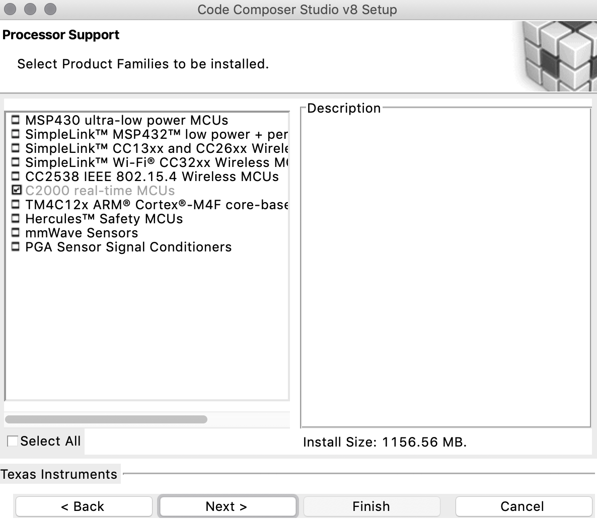

## Download and Install C2000Ware

<http://www.ti.com/tool/c2000ware>

# Create First CCS Project

1. From the main CCS window select File -> New -> CCS Project.
2. Name your project and choose a location for it to reside. Connect the device and verify the connection under *Texas instruments XDS100v2.*

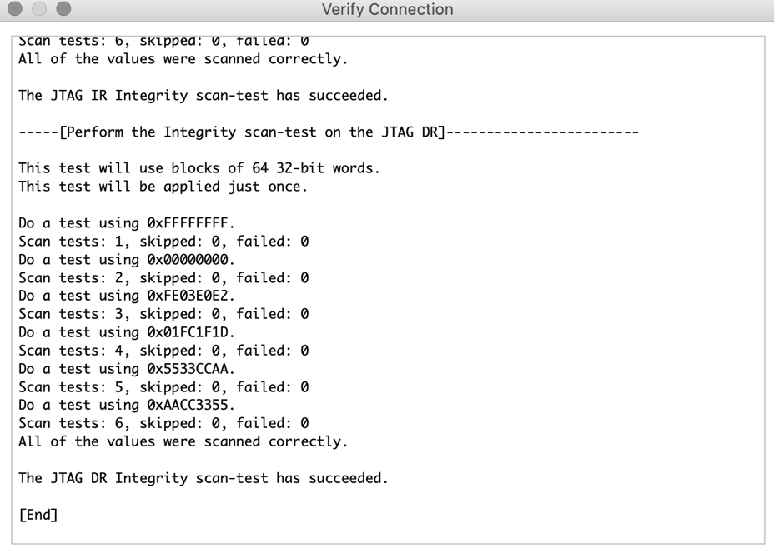

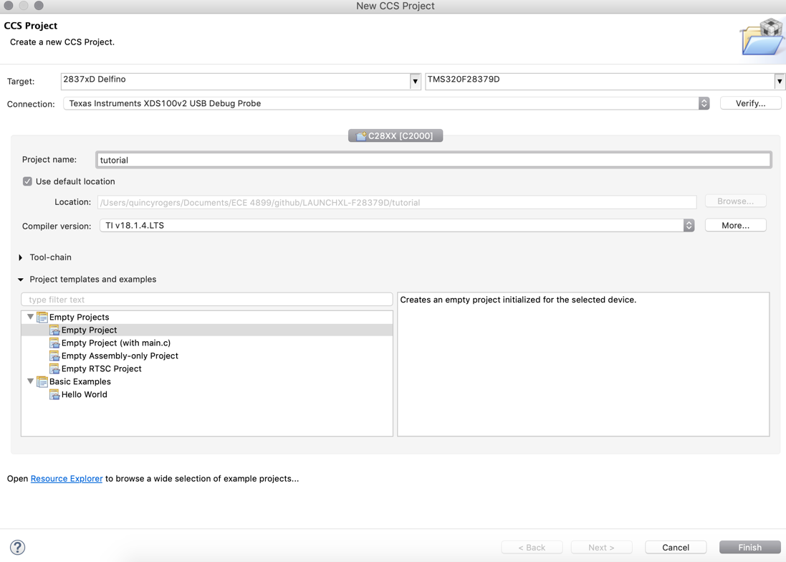

Click Finish and your project will be created.

1. Before we can successfully build a project, we need to setup some build specific settings. Right click on your project and select Properties. Look at the Processor Options and ensure they match the below image:



1. In the C2000 Compiler entry look for and select the Include Options. Click on the add directory icon to add a directory to the search path. Click the File System button to browse to the common\include folder of your C2000Ware installation (typically C:\ti\c2000\C2000Ware_X_XX_XX_XX\device_support\f2837xd\common\include). Replace the ’X’s with your current C2000Ware version installation. Click ok to add this path and repeat this same process to add the headers\include directory. Add the following include directory path to the project: driverlib\f2837xd\driverlib.



1. Expand the Advanced Options and look for the Predefined Symbol entry. Add a Pre-define NAME called "CPU1". This ensures that the header files build correct for this CPU. If using a Launchpad, also add a pre-define NAME called "_LAUNCHXL_F28379D". This is required to setup the proper device clocking.



1. Click on the Linker File Search Path. Add these directories to the search path: common\cmd and headers\cmd. Then you’ll also want to add the following files: rts2800_fpu32.lib, 2837xD_RAM_lnk_cpu1.cmd, and F2837xD_Headers_nonBIOS_cpu1.cmd. Finally, delete libc.a, we will use rts2800_fpu32.lib as our run time support library instead.



1. In the project explorer, check that no linker command file got added during project setup. If so, remove the linker command file that got added. Additionally, check in the project properties under the General tab and verify that the linker command text box is blank.

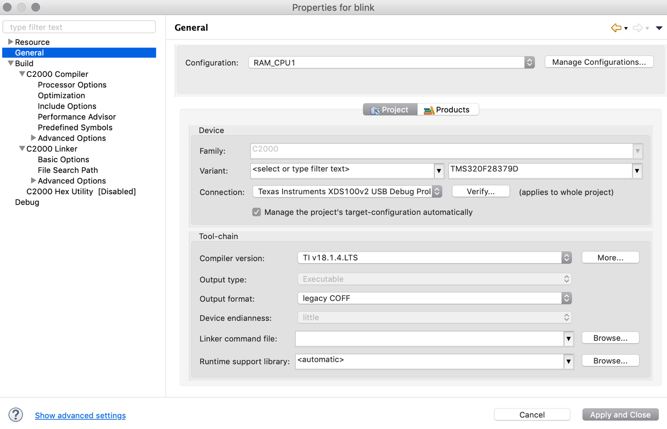

1. Next, we need to link in a few files which are used by the header files. To do this right click on your project in the workspace and select Add Files... Navigate to the headers\source directory, and select F2837xD_GlobalVariableDefs.c . After you select the file, you’ll have the option to copy the file into the project or link it. We recommend you link files like this to the project as you will probably not modify these files. In addition, link in the following files as well:

* common\source\F2837xD_CodeStartBranch.asm
* common\source\device.c
* driverlib\f2837xd\driverlib\ccs\Debug\driverlib.lib

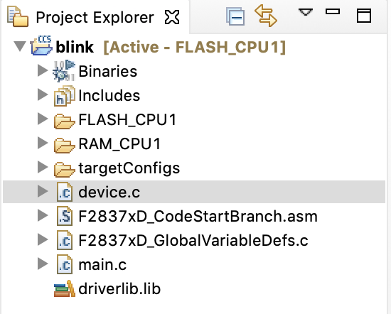

1. Create a new file by right clicking on the project and selecting New -> File. Name this file main.c and copy the following code into it:
2. #include "driverlib.h"
3. #include "device.h"
5. **void** main(**void**)
6. {
7. /* *************************************************************************************
8. * The delay function is supposed to be run from RAM. If you're loading code into flash,
9. * somewhere in your code you'll need to copy SysCtl_delay() from flash to RAM.
10. * If you're using Device_init(), it will do the memcpy for you as long as you
11. * have _FLASH in your predefined symbols.
12. **************************************************************************************/
14. Device_init();
16. Device_initGPIO();
17. GPIO_setPadConfig(DEVICE_GPIO_PIN_LED1, GPIO_PIN_TYPE_STD);
18. GPIO_setDirectionMode(DEVICE_GPIO_PIN_LED1, GPIO_DIR_MODE_OUT);
20. **while**(1)
21. {
22. // Turn on LED
23. GPIO_writePin(DEVICE_GPIO_PIN_LED1, 0);
25. // Delay for half a second
26. DEVICE_DELAY_US(500000);
28. // Turn off LED
29. GPIO_writePin(DEVICE_GPIO_PIN_LED1, 1);
31. // Delay for half a second
32. DEVICE_DELAY_US(500000);
33. }
34. }
35. Save main.c and then attempt to build the project by right click on it and selecting Build Project. Assuming the project builds try debugging this project on a F2837xD device, otherwise carefully examine the error and the above steps to determine what could have gone wrong.
36. Create a new configuration from the existing configuration to flash the development board.

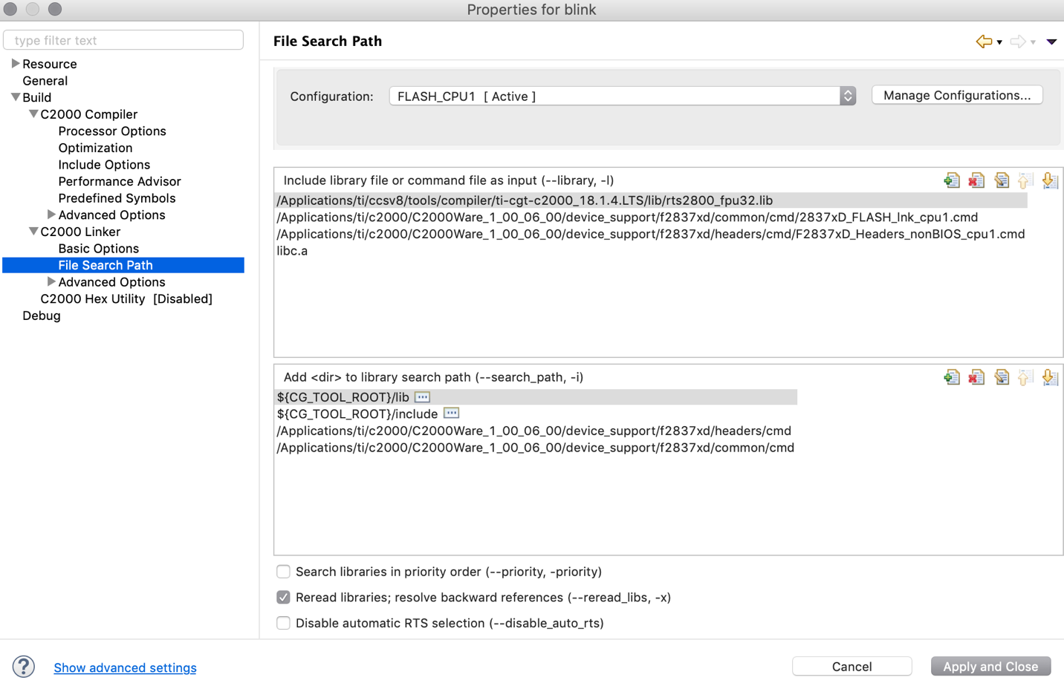

1. Save main.c and then attempt to build the project by right click on it and selecting Build Project. Assuming the project builds try debugging this project on a F2837xD device, otherwise carefully examine the error and the above steps to determine what could have gone wrong.